Instructions for printing vocabulary cards

The Granite District Vocabulary Cards are excellent resources. The cards contain words and definitions aligned to the Utah Core Standards. The engaging pictures help students develop a conceptual understanding of the definitions.

By changing a simple setting on your printer function you can extend the use of your cards. The cards can easily be duplicated for use in partner games or small groups.

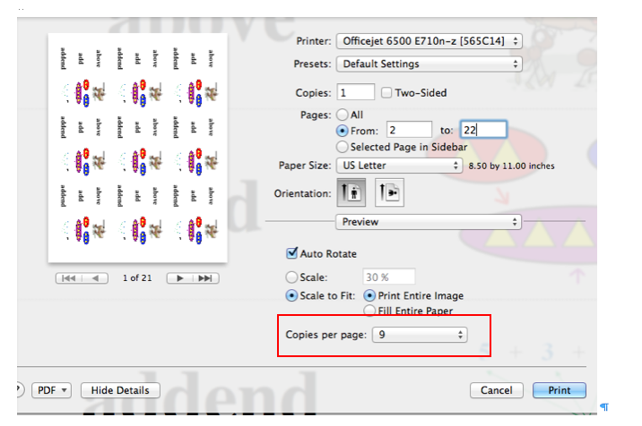

Experiment with the copies per page. You can make simple matching games by printing smaller cards and cutting the words and pictures in half. You can print single cards or cards in a complete set.

